Getting an offline web site

Requirement

- HTTrack Website Copier - http://www.httrack.com/
- Url of the site
- Make sure to know list of pages you wanted

[Note: In HTTrack dose not replaces the url’s if the pages is not listed in the Web Addresses box. ]

- Create a Project
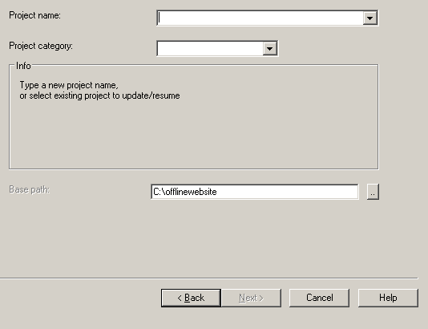
- Enter all the pages you wanted to be offline.
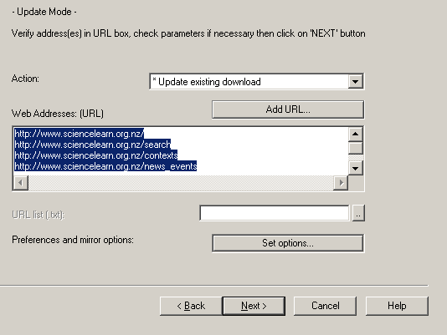
- Make sure set up the limits, otherwise the software will try to download all pages as well as the other sites link to it until size limit is reached.
